Robot Risk Assessment Report
  - Project Name – Project Code

Contents
Project Summary 3
Revision Log 4
Description of Application 5
Narrative 5
General Comments 5
Task List 6
Hazard List 7
Risk Reduction Measures 8
Task 1: XXX 8
Appendix A: Injury Severity, Exposure, and Avoidance Factors 9
Appendix B: Risk Level Decision Matrix 11
Risk Level Decision Matrix 11
Appendix C: Minimum Risk Reduction Measures Required Functional Safety Performance 12
Minimum Risk Reduction Measures as a function of the risk level 12
Minimum Functional Safety Performance 12
Cell Mechanical Layout 13

Project Summary

Company | Silver Hills Bakery
Project Identification
Project Description
Robot Manufacturer
Robot Model Number
Robot Year of Manufacture
System Year of Manufacture

Report prepared by
Date
Report approved by
Date

Revision Log
Revision | Date | Changes
A | 20XX.XX.XX | Initial document creation

Description of Application

Narrative
Describe the system as it functions.

General Comments
- XXX

Task List
 | Task | Hazards | Notes

Hazard List
 | Hazard | Severity | Exposure | Avoidance | Risk Level

To be performed in accordance with CAN/CSA-Z434-14 and RIA TR R15.306-2016

Risk Reduction Measures

Task 1: XXX
Hazard | Severity | Exposure | Avoidance | Risk Level | Risk Reduction Measures | Severity | Exposure | Avoidance | Risk Level

Appendix A: Injury Severity, Exposure, and Avoidance Factors
Factor | Rating | Criteria
Injury Severity | Serious  S3 | Normally non-reversible; likely will not return to the same job after recovery from incident:  - Fatality  - Limb amputation  - Long Term Disability  - Chronic Illness  If any of the above are present, the rating is SERIOUS
Injury Severity | Moderate  S2 | Normally reversible; likely will return to the same job after recovery from incident:  - Broken bones  - Severe laceration  - Short hospitalization  - Short term disability  - Lost time (multi-day)  - Fingertip amputation (not thumb)  If any of the above are applicable, the rating is MODERATE
Injury Severity | Minor  S1 | First aid; no recovery required before returning to job:  - Bruising  - Small cuts  - No loss time (multi-day)  - Does not require attention by a medical doctor  If any of the above are applicable, the rating is MINOR
Exposure | Prevented  E0 | - Exposure to hazard(s) us eliminated/ controlled /limited by inherently safe design measures.  - Use of guards prevents exposure or access to the hazards(s). If an interlocked guard is selected, the following bullet must also be met.  - If functional safety is used as a risk reduction measure, the implemented functional safety performance (PL) meets or exceeds the required functional safety performance (PL). See Part 2, 5.2.  If any of the above are applicable, the rating is PREVENTED
Exposure | High  E2 | - Typically, more than once per day or shift  - Frequent of multiple short duration  - Situations which could lead to increases in the duration of a task not to include teaching tasks  If any of the above are applicable, the rating is HIGH
Exposure | Low  E1 | - Typically, less than or once per day or shift  - Occasional short durations  - If any of the above are applicable, the rating is LOW
Avoidance | Not Possible  A3 | - Insufficient clearance to move out of the way and safety-rated reduced speed control is not used  - The robot system or cell layout causes the operator to be trapped, with the escape route toward the hazard  - Safeguarding is not expected to offer protection from the process hazard (eg. Explosion or eruption hazard)  If any of the above are applicable, the rating is NOT POSSIBLE
Avoidance | Not Likely  A2 | - Insufficient clearance to move out of the way and safety-rated reduced speed control is used  - Obstructed path the move to safe area  - Hazard is moving faster than reduced speed (250 mm/s)  - Inadequate warning/reaction time  - The hazard in imperceptible  If any of the above are applicable, the rating is NOT LIKELY
Avoidance | Likely  A1 | - Sufficient clearance to move out of the way  - Hazard is incapable of moving greater than reduced speed (250 mm/s)  - Adequate warning/reaction time  - Positioned in a safe location away from the hazard  If any of the above are applicable, the rating is LIKELY

Appendix B: Risk Level Decision Matrix

Risk Level Decision Matrix
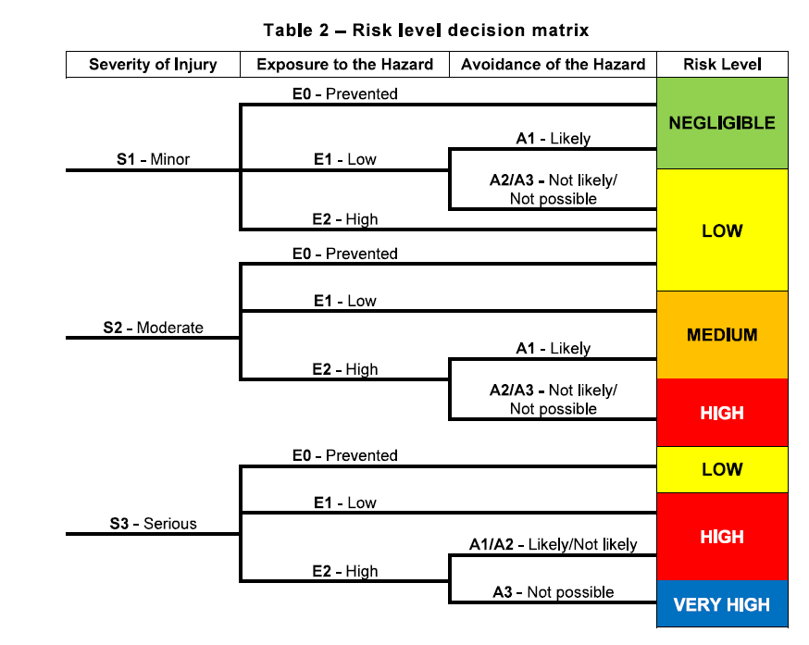

Appendix C: Minimum Risk Reduction Measures Required Functional Safety Performance

Minimum Risk Reduction Measures as a function of the risk level
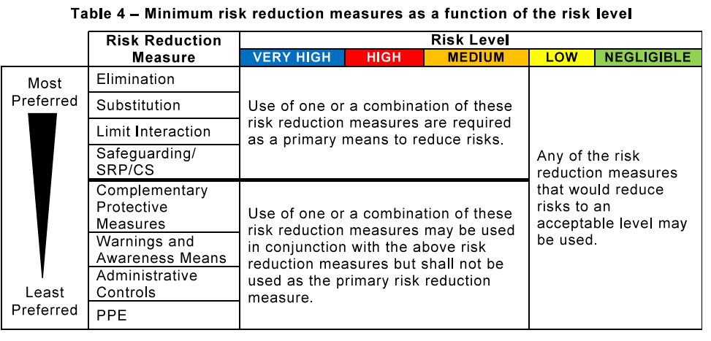

Minimum Functional Safety Performance
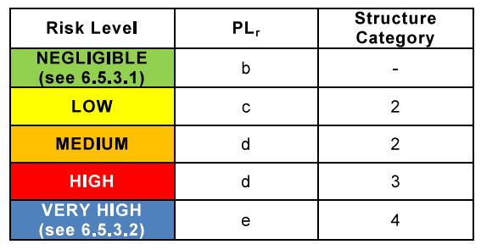

Cell Mechanical Layout
[Insert appropriate views of the robot cell]

